

**Orient HBU-50CA03T3**

**Rs. 240,000/-**

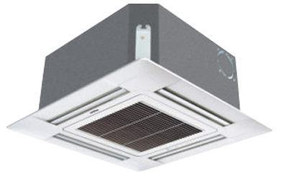

**Product Features**

* Reserved Air Outlet
* State of the Art
* Air Vane Technology
* Auto Swing
* power mode

**Specification**

**Type** Ceiling Cassette AC

**Cooling (Btu/h)** 42000

**Voltage (V)** 220-240

**Power Input (W)** 3400

**EER (Btu/W-h-W/W)** 4.3-2.1